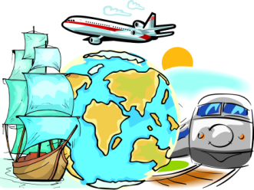
A lot of people travel nowadays. It isn’t surprising because distances between countries are becoming shorter due to the development of transport. Today people have lots of good reasons to travel. First of all, travelling is a part of people’s education. Besides, travelling is a good way to practice foreign languages. Another reason why people travel is to relax. Finally, more and more people nowadays travel around the world on business.
The main forms of public transport are buses, trains, ships and planes. Each of them has pros and cons.
Of course, air travel is quicker than other means of transport. Travelling by train is one of the most popular means of travelling. First of all, it’s cheaper than travelling by air. Besides, modern trains are very comfortable.
Some people prefer travelling by sea which is very exciting. But of course, if you are sea-sick, travelling by ship isn’t a good idea.
A lot of people travel by car because it’s rather convenient. They don’t have to buy tickets and to carry heavy luggage. They can stop wherever they wish and spend as much time as they like at any place. However, this way of travelling is not as comfortable and quick as travelling by plane or by train.
Some people are against travelling. They say that tourists have no respect for the countries they visit. A lot of tourist places are polluted and many of historical monuments are in danger of being destroyed by unstoppable (бесконечный) march of tourism. Besides, today travelling is rather expensive. That’s why some people prefer to spend their holidays in the country or at home in front of TV.
As for me, I enjoy travelling very much because travel broadens the mind. It’s always interesting to see other countries and continents, to discover different ways of life, meet different people and to try foreign food. While travelling we can see and learn a lot of things that we can never learn staying at home and watching TV or reading books. In summer my parents and I usually go to Greece because it has a wonderful climate, a warm sea, clean beaches and comfortable hotels.

